**FAQ accordion**

**You have 30 minutes to create a FAQ accordion that each question can be clicked and expanded.** 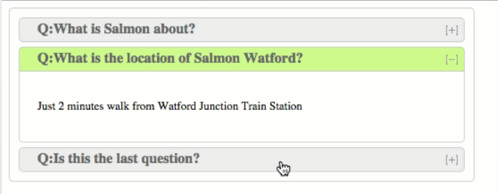

|  |  |
| --- | --- |
| **We are looking for:**   * **HTML, CSS and JavaScript** are all attempted * For it to look **presentable** - but does not have to be ‘pixel perfect’ * FAQ’s are rendered dynamically : FAQ’s are provided in **JSON** format. Ideally these would be **AJAX**’d in. * **Clean** code * Something that **works after 30 minutes**! | * You **may use** the internet to lookup information * **DO NOT copy and paste** code from another site |

**URL:** [**http://plnkr.co/edit/ps8CaXvqxzblHiBGJxLH**](http://plnkr.co/edit/ps8CaXvqxzblHiBGJxLH)

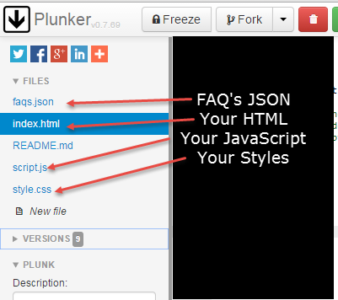

**Don’t forget to save as you go:** 